Osman Kantarcıoğlu
30891
CS210
Project Step 3

Introduction

The objective of the third phase of the project is applying the machine learning methods that are learned in the course by using the statistical analysis which is done in Phase 2. This long journey involves three primary stages: Building two machine learning model, verifying these models and deciding which machine learning performs better and the reason why this model performs better. At the end of these three stages, the goal is building most appropriate machine learning model for statistical analysis.

Building Two Machine Learning Model

k-Nearest Neighbors Method As a First Machine Learning Model:
A simple yet effective machine learning algorithm is kNN. The core concept of kNN involves examining the neighborhood of a given instance. It is a supervised algorithm that can be utilized in both classification and regression tasks. The algorithm computes the distance between a new data point and all other training data points. It then identifies the K-nearest data points, where K is an integer value. Finally, it assigns the new data point to the class that the majority of these K-nearest data points belong to. In this project kNN will be applied for regression tasks.

In this context, K is a hyperparameter. A hyperparameter is a model parameter that is set before the training process starts. In the project, the test is done again and again to find best K value that corresponds to lowest RMSE and highest accuracy.

k-Nearest Neighbors Method have been applied to all K values from 0 to 20 and for each k values RMSE is calculated separately. RMSE, or Root Mean Squared Error, is a widely used metric for assessing the accuracy of a predictive model, especially in regression analysis. It is determined by taking the square root of the average squared differences between the predicted values and the actual values. RMSE offers a measure of how closely a model's predictions align with the observed data and gives a sense of the magnitude of prediction errors.

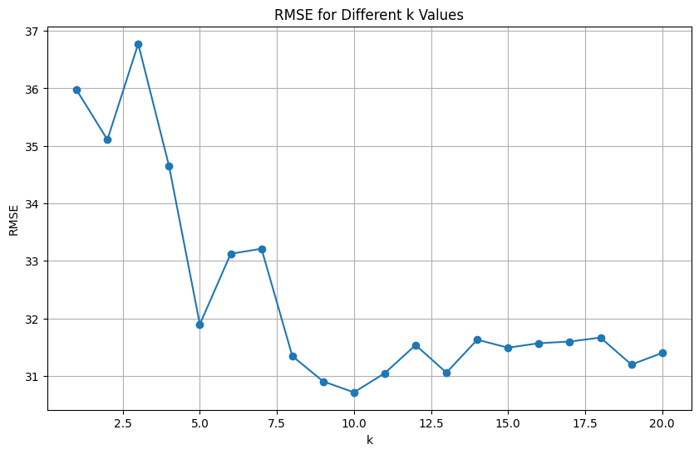

As can be seen from the plot above there is a wide range of K values in x axis and their corresponding RMSE (Root Mean Squared Error) values. Initially, the RMSE is relatively high for lower k values, particularly between 1 and 3, with noticeable fluctuations. As the k value increases, the RMSE generally decreases, reaching its lowest point around k = 10 to 12. Beyond this range, the RMSE stabilizes with only minor variations, indicating a consistent error rate for k values between 12 and 20. This suggests that the optimal performance of the kNN model, characterized by the lowest RMSE, is achieved when k is around 10 to 12. Beyond this range, the choice of k has a minimal impact on the model's performance.

As its name implies, RMSE indicates the error margin. To achieve the best performance from machine learning method, the K value that corresponds to the lowest error rate should be sellected. Consequently, this model performs optimally at k=10.

Random Forest Method As a Second Machine Learning Model:

Random Forest is a powerful ensemble learning method that combines multiple decision trees through random feature selection and a bootstrapping approach. Like decision trees, it handles both classification and regression tasks. During training, it constructs numerous decision trees, each using a random subset of features and data samples obtained through bootstrapping. These trees operate independently, with classification results determined by majority voting and regression predictions averaged across all trees.

Aim is to find most suitable parameter for Random Forest Machine Learning Model. n_estimators and max_depth are two well-known parameters. The heatmap illustrates the Root Mean Squared Error (RMSE) scores resulting from a grid search to find a machine learning model's hyperparameters. The x-axis denotes the number of estimators (n_estimators), ranging from 50 to 500, while the y-axis represents the maximum depth (max_depth) from 1 to 15. Colours indicate RMSE values, with yellow representing higher errors around 34 and dark red to black indicating lower errors around 24.7439. Optimal performance, signified by the lowest RMSE scores, is observed with a max_depth of 4 and n_estimators of 500. Conversely, the highest RMSE scores occur with a max_depth of 1 and around 50 n_estimators.
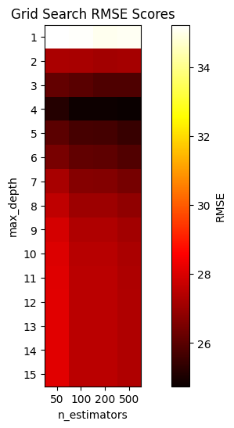
To sum up, as also can be seen from the plot above best parameters for Random Forest Method are 500 for n_estimatior and 4 for max_depth which corresponds to lest RMSE.
Verify your Models

Evaluation metrics are crucial tools in assessing machine learning model performance, providing quantitative measures to gauge effectiveness in various tasks. These metrics playing a role in decision-making regarding model selection. In regression analysis, metrics like MAE, MSE, RMSE, and R-squared offer valuable insights into model accuracy and reliability.

Root Mean Squared Error (RMSE) has been preferred in this project. RMSE is a commonly used metric to evaluate the performance of regression models. It measures the average magnitude of the errors between the predicted values and the actual values in the dataset. It is commonly used in regression tasks because it is in the same units as the target variable, making it easy to interpret and compare across different datasets and models.

After trying different parameters for K values, k-Nearest Neighbors model as a first machine learning model works more accurately when k= 10. Therefore, least RMSE value is corresponds to k=10 and it is 30.71420974765715.

Again, after trying different parameters for n_estimatior and max_depth, Random Forest model as a second machine learning model works more accurately when max_depth= 4 and n_estimators=500. Therefore, least RMSE value is corresponds to max_depth= 4 and n_estimators=500 and it is 24.743983978613016.

To conclude, evaluation matrices such as RMSE give a chance to determine which machine learning model provide the most accurate predictions for dataset. These RMSE will be used in last part to decide which model should be used.

Deciding Which Machine Learning Model Performs Better and the Reasons Behind It

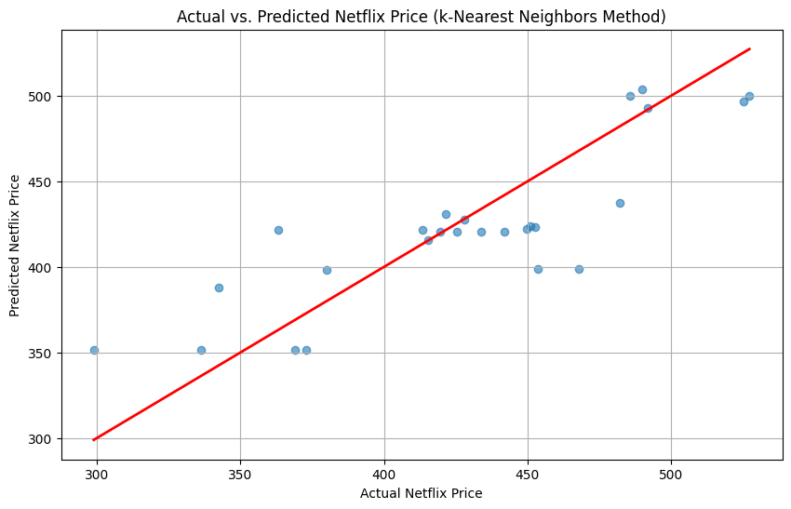

Using the k-Nearest Neighbors (k-NN) approach, this scatter plot illustrates the link between the actual and predicted prices of Netflix stock. The y-axis shows the expected pricing, and the x-axis shows the actual Netflix prices. Every blue dot represents two different prices (the real and the expected). The ideal situation, represented by the red line, is one in which the anticipated price exactly equals the actual price. The predictions are more accurate the closer the blue dots are to the red line.
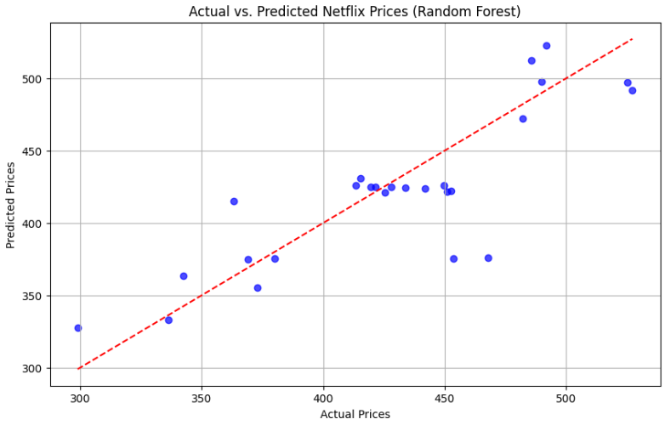

Similar to Actual vs. Predicted Netflix Price (k-Nearest Neighbors Method) plot some of the blue dots are clustered close to the ideal line and some of the blue dots are far from the ideal line. However, ‘most’ points closer to the ideal line in this plot as opposed to Actual vs. Predicted Netflix Price (k-Nearest Neighbors Method) plot.

The reason of why ‘most’ points in Random Forest plot closer to the ideal line is related to RMSE. The RMSE (Root Mean Squared Error) is a measure of how well the model's predictions match the actual values. RMSE of Random Forest Model is 24.743983978613016. Whereas RMSE of the k-Nearest Neighbors Method is 30.71420974765715. Since the Random Forest model has a lower RMSE (24.74) compared to the k-NN model (30.71), it indicates that the Random Forest model makes more accurate predictions on dataset. Therefore, the Random Forest model is the better choice based on this evaluation metric when Random Forest have parameters max_depth= 4 and n_estimators=500 and k-Nearest Neighbors Method has parameter k=10.

BRIEF SUMMARY
In the third phase of the project, two machine learning models, k-Nearest Neighbors (k-NN) and Random Forest, were developed and evaluated to build the most appropriate model for statistical analysis with different parameters. The k-NN model was tested with k values from 0 to 20, identifying k = 10 as the optimal value with an RMSE of 30.71. The Random Forest model underwent a grid search to find the number of estimators and maximum depth, finding optimal values of 500 and 4, respectively, resulting in an RMSE of 24.74. Comparing the models, the Random Forest model demonstrated superior performance, evidenced by a lower RMSE, indicating it provided more accurate predictions and was better suited for the data analysis.

References:
- https://www.kaggle.com/datasets/saketk511/2019-2024-us-stock-market-data?resource=download
- https://www.kaggle.com/datasets/aditeloo/the-world-dataset-of-covid19

